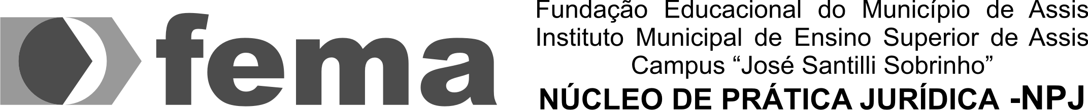

ALUNO |  |  |  | VISTO DO PROFESSOR
Nº RA | SÉRIE | TURNO | DATA | VISTO DO PROFESSOR
DISCIPLINA |  | PROFESSOR |  | VISTO DO PROFESSOR
ATIVIDADE PRÁTICA (INCLUSIVE Nº DE ORIGEM) |  |  |  | VISTO DO PROFESSOR

________________________________________________________________________________________________________________________________________________________________________________________________________________________________________________________________________________________________________________________________________________________________________________________________________________________________________________________________________________________________________________________________________________________________________________________________________________________________________________________________________________________________________________________________________________________________________________________________________________________________________________________________________________________________________________________________________________________________________________________________________________________________________________________________________________________________________________________________________________________________________________________________________________________________________________________________________
_______________________________________________________________________________________________________________________________________________________________________________________________________________________________________________________________________________________________________________________________________________________________________________________________________________________________________________________________________________________________________________________________________________________________________________________________________________________________________________________________________________________________________________________________________________________________________________________________________________________________________________________________________________________________________________________________________________________________________________________________________________________________________________________________________________________________________________________________________________________________________________________________________________________________________________________________________________________________________________________________________________________________________________________________________________________________________________________________________________________________________________________________________

